Improving energy efficiency in cloud computing through optimized machine learning based resource allocation

Abstract-This paper proposes a machine learning–based optimized resource allocation strategy to enhance energy efficiency in cloud computing environments. The system begins by collecting and pre-processing workload and resource datasets, including handling missing values, normalization, and label encoding. Machine learning classifiers, namely Support Vector Machine (SVM) and 1D Convolutional Neural Network (CNN-1D), are employed to predict workload patterns and resource demands with high accuracy. Based on these predictions, task scheduling is performed by analyzing the capacity of virtual machines (VMs) and processors. In cases of mismatched capacity or overload, the system dynamically initiates server scaling and VM migration to maintain service continuity. To optimize workload distribution, the Honey Badger Algorithm (HBA) is integrated, leveraging its exploration and exploitation phases to balance throughput, system load, and energy efficiency. Robust fault tolerance is achieved through Reliable Broadcast (RBC) and Asynchronous Common Subset (ACS) protocols, ensuring secure and consistent communication across distributed nodes. Furthermore, an adaptive batching mechanism dynamically adjusts task batch sizes based on real-time throughput and load, while Round Robin scheduling guarantees fairness in resource allocation. Experimental evaluation demonstrates that the proposed strategy significantly reduces energy consumption while sustaining high system performance in terms of execution time, throughput, and resource utilization. Performance is further validated using accuracy, precision, recall, F1-score, and error rate metrics.

Keywords: Cloud Computing, Resource Allocation, Energy Efficiency, Machine Learning, Support Vector Machine (SVM), 1D Convolutional Neural Network (CNN-1D), Honey Badger Algorithm (HBA), Task Scheduling, Virtual Machines (VMs), Server Scaling, VM Migration, Adaptive Batching, Fault Tolerance, Reliable Broadcast (RBC), Asynchronous Common Subset (ACS), Round Robin Scheduling.

I INTRODUCTION
Cloud computing has become the backbone of modern digital infrastructure, offering scalable, on-demand services for enterprises, governments, and individuals. However, the rapid growth of data centers to support cloud services has led to a significant increase in energy consumption, which not only raises operational costs but also contributes to environmental concerns such as carbon emissions. Studies show that energy inefficiency in resource allocation is one of the primary challenges in achieving sustainable cloud operations. Traditional static or rule-based scheduling methods often fail to adapt to the dynamic and heterogeneous workloads of cloud environments, resulting in resource underutilization, server overloading, and unnecessary power consumption. To address these limitations, machine learning (ML) has emerged as a powerful tool for intelligent resource allocation in cloud computing. ML models can learn from historical workload patterns and real-time system data to predict resource demands accurately and allocate them optimally. By doing so, ML-based resource management not only enhances performance and scalability but also minimizes energy wastage by ensuring that computing resources are neither over-provisioned nor under-utilized. Furthermore, the integration of ML with energy-aware scheduling policies enables cloud providers to strike a balance between quality of service (QoS) and energy efficiency, aligning with global sustainability goals.
This study focuses on improving energy efficiency in cloud computing through optimized machine learning–based resource allocation. The proposed approach leverages predictive analytics and adaptive optimization to dynamically manage workload distribution, reduce energy overhead, and enhance overall system sustainability. By combining data-driven intelligence with resource-efficient strategies, the work contributes toward the development of greener, cost-effective, and future-ready cloud infrastructures.
Cloud services are extensively employed by both companies and individuals in the 21st and 22nd centuries due to their efficiency and dependability among others. One of the significant aspects of cloud data centers is to ensure that their management techniques produce energy reduction and reduction in the environmental impact. Therefore, it is critical to deploy new techniques or enhance existing ones to ensure that the resources required to reduce energy consumption are maximally allocated to balance the load in the deployment of leading-edge technology such as the Internet of things, and blockchain technology, among others. In large-scale distributed computing, where machines are networked to tackle difficult optimization problems, resource allocation is an extremely important aspect of the process. Within the scope of this discussion, the objective of resource allocation is to achieve maximum overall computing efficiency or throughput [20, 32]. Contrast this with grid computing, in which disparate clusters in different locations are interconnected and made available to users, and it becomes clear that cloud computing is a unique concept. Cloud computing has quickly become the de facto standard for network infrastructure in the IT industry. Increases in both the number of people using and paying for Internet-based services are factors in the meteoric ascent of cloud computing components There is now no doubt that cloud computing is the most cost-effective IT breakthrough for business use. Because of this, small, medium, and failing businesses now have a fighting chance against larger enterprises by having access to computer hardware. It is a system that tries to evolve with very few or no limits because of its freedom of use, which is achieved through virtualization and software that is service-oriented.
The utilization of computer resources may now be carried out in one of three separate ways as a direct result of cloud technology. There is no need to worry about the stress and initial expense of procuring equipment, premises, and the IT supply chain. These strategies include, among other things, the ability to be flexible and pay for services on an as-needed basis. In the same way that we use water and gas daily, the cloud computing environment provides users with access to information technology resources. By connecting to a remote server located in a data centre, managed by a third party such as Microsoft Azure, Amazon Web Service (AWS), Facebook, or Google, customers can access a wide range of network, storage, computational, and software capabilities. Cloud innovation has gained a large amount of attention across the research, industry, academic, and commercial sectors due to its performance features (use flexibility, swift resource aggregation, network predominance, and so on), as well as its fast-growing percentage of IT expenditure. According to the National Institute of Standards and Technology (NIST), “cloud computing” is “a framework that enables widespread, comfortable, on-demand internet backbone access to a consensual pool of resources that can be rapidly allocated and initiated with minimal coordination by the service provider” [24].
Allocating virtualized information and communication technology resources in a cloud computing paradigm is a difficult problem to solve because different application workloads (MapReduce, content distribution, and network web applications) exist with conflicting requirements for the allocation of information and communication technology resource capacity (response time, execution time, resource utilization, etc.). Due to limited available resources and growing customer demands, this job of resource allocation becomes increasingly difficult. As a result, several novel models and strategies have been developed to efficiently distribute resources. Some techniques have made use of dynamic resource allocation methods and models, which centre their attention on a variety of restrictions or objectives to optimize resource allocation. The energy-saving scheduling of data centers is critical for cloud service providers and will also contribute to environmental sustainability. The major problem in the currently in cloud computing energy optimization research is that there are limited critical reviews articles for machine learning based approaches in cloud computing energy optimization to direct and help researchers.[8-9] There are to the best of our knowledge no reviews that can suggest the best ML model, tools, datasets, and evaluation metrics for current and future research. This study provides a comprehensive review of energy efficiency in cloud computing using ML techniques and extensively compares and contrasts different ML approaches.[10-13]

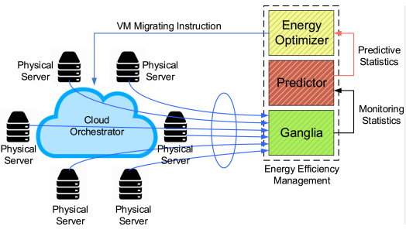

Fig.1 Energy efficiency for cloud computing system
Energy efficiency in cloud computing can be enhanced through strategies such as virtualization, which consolidates resources and reduces hardware requirements, and load balancing, which ensures optimal utilization of servers. Energy-aware scheduling, task allocation based on demand, and the use of energy-efficient hardware like low-power processors and SSDs also contribute to reduced consumption. Additionally, integrating renewable energy sources, employing advanced cooling techniques, and adopting edge computing to process data closer to users help minimize energy use. Server sleep modes, power capping, and optimizing cloud applications further reduce energy wastage, while green cloud computing frameworks and monitoring tools enable better decision-making and sustainability. These approaches not only lower costs but also decrease the environmental footprint of cloud infrastructures.
II RELATED WORK
Preeti Narooka et al. (2023): Focused on the importance of the Internet of Things (IoT) for business, particularly in automating tasks and improving resource management in cloud environments. Their study emphasized how IoT can lead to better control over resources and improved operational efficiency by automating tasks and facilitating more informed decision-making.[14]
Lei Li et al. (2025): Proposed a proactive cloud resource scheduling framework to improve cloud resource allocation using an adaptive LSTM-based workload prediction method. The method aims to improve predictive accuracy and cloud service profit by optimizing resource allocation for virtual machines (VMs), reducing delays and increasing service profitability.[15]
Vivek Kumar Prasad et al. (2023): Developed a versatile framework for adapting e-commerce applications to IoT and cloud computing (CC) environments. Their framework uses a set of metrics to support service-level agreements (SLAs) and automate cloud resource management, reducing the need for manual interventions and enhancing efficiency and reliability in resource allocation.[16]
Abdulghafour Mohammad et al. (2024): Investigated the challenges small and medium enterprises (SMEs) face in cloud resource allocation. Their research identified key barriers using qualitative interviews across four countries and proposed solutions to help SMEs implement effective strategies for utilizing cloud computing resources.[17]
Ali M. Abshaev et al. (2023):Explored rain enhancement through cloud seeding in Minas Gerais, Brazil, by analyzing multi-year climate and meteorological data. They assessed the potential for improving precipitation to help mitigate water scarcity, proposing a methodology for evaluating the feasibility of weather modification in water management’s[18]
Vinoth Kumar et al. (2023): Examined cloud resource management in businesses, focusing on monitoring and optimizing resource usage to ensure compliance with service-level agreements (SLAs). Their study emphasized automating IT operations and improving control over resource allocation using a cloud resource management system.[19]
Arun Kumar Sangaiah et al. (2023): Developed an intelligent system for responding to approximate queries in peer-to-peer databases. They used particle optimization to enhance query handling efficiency, reducing costs and time required for query execution while improving the system's overall performance.[20]

III MATERIAL AND METHODS
Dataset
The dataset contains 5,000 unique task execution records collected from a simulated cloud environment with workloads resembling IoT-generated logs. It is designed to analyze cloud workload scheduling strategies and optimize resource allocation efficiency. Each record corresponds to a single job/task execution in the cloud infrastructure. The primary goal of this dataset is to evaluate scheduling algorithms (e.g., FCFS, Round Robin, Priority-Based) in terms of performance metrics like CPU usage, memory utilization, throughput, and waiting time, with Scheduler_Type as the target variable.https://www.kaggle.com/datasets/zoya77/cloud-workload-dataset-for-scheduling-analysis

Table 1 Dataset Description
Column Name | Description
Job_ID | Unique identifier for each cloud task execution.
Task_Start_Time | Timestamp marking the beginning of task execution.
Task_End_Time | Timestamp marking the completion of task execution.
CPU_Utilization (%) | Percentage of CPU resources consumed during task execution.
Memory_Consumption (MB) | Memory utilized by the task (in MB).
Task_Execution_Time (ms) | Time taken to complete the task (end-to-end) in milliseconds.
System_Throughput (tasks/sec) | Number of tasks successfully executed per second.
Task_Waiting_Time (ms) | Time task spent waiting in the scheduling queue before execution.
Data_Source | Origin of the task (IoT devices, cloud platforms, social media, enterprise DBs).
Number_of_Active_Users | Concurrent users utilizing cloud resources during task execution.
Network_Bandwidth_Utilization (Mbps) | Network bandwidth consumed during task execution.
Job_Priority | Assigned priority level of the task: High / Medium / Low.
Scheduler_Type | Scheduling algorithm used (FCFS, Round Robin, Priority-Based).
Resource_Allocation_Type | Type of resource allocation: Dynamic or Static.
Error_Rate (%) | Percentage of errors/failures encountered during task execution.

Support Vector Machine
A well-known method in Supervised Learning is the Support Vector Machine (SVM). Both Classification and Regression jobs are often done with it. But its main use is to solve Classification problems in the area of Machine Learning. The Support Vector Machine (SVM) method aims to create the best line or decision boundary that can effectively divide an n-dimensional space into distinct classes. This will allow future data points to be correctly classified. The decision boundary that optimally separates the data points is referred to as a hyperplane.SVM selects the most significant points/vectors that contribute to the construction of the hyperplane [22].These exceptional instances are referred to as support vectors, so the approach is known as Support Vector Machine. Examine the diagram below, which illustrates the classification of two distinct categories using a decision boundary or hyper planes:
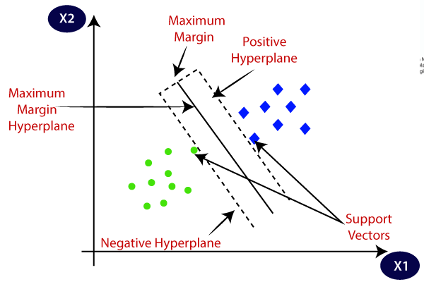
Fig. 2 SVM algorithm

SVM Algorithm
Initialization:
Given a training dataset
𝐷={(𝑥𝑖,𝑦𝑖)} Eq.6
Where is the feature vector and 𝑦𝑖​ is the class label (either -1 or +1 for binary classification).
Choosing the Hyperplane:In a simple linear SVM, the hyperplanes can be written as 𝑤⋅𝑥+𝑏=0, where w is the normal vector to the hyperplane, and b is the bias term.
Optimization Problem: The objective is to maximize the margin, which can be expressed as:
Maximize $\frac{2}{‖w‖}$
This is subject to the constraint that each data point is correctly classified:
(𝑤⋅𝑥_{𝑖}+𝑏)≥1,∀_{𝑖} Eq.8
1D Convolutional
A 1D Convolutional Layer (Conv1D) in deep learning is specifically designed for processing one-dimensional (1D) sequence data. This type of layer is particularly useful for tasks involving temporal sequences such as audio analysis, time-series forecasting, or natural language processing (NLP), where the data is inherently linear and sequential.
The primary operation in a Conv1D layer involves sliding a convolutional filter (or kernel) across the input sequence. This filter is a set of learnable weights that the network adjusts during training. The convolution operation multiplies the values of the filter by the original input values in a segment of the sequence, summing up the results to produce a single output point. This process is repeated across the entire sequence, generating a transformed sequence as output.

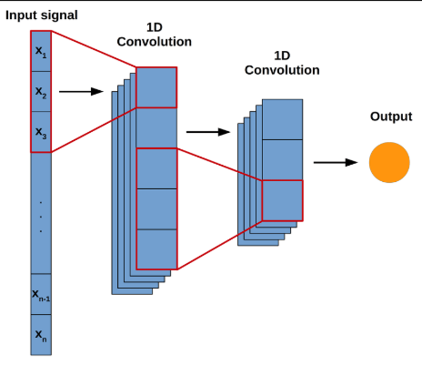

Fig.3 1D Convolutional
A 1D convolutional layer is a type of neural network layer that performs convolution operations on one-dimensional data. Unlike 2D convolutions that slide a kernel over a two-dimensional input (e.g., images), 1D convolutions slide the kernel along a single spatial dimension. The input is typically represented as a sequence or a signal. Examples include time-series data, text embeddings, and audio waveforms. The shape of the input data is (batch_size, sequence_length, num_features).The layer uses a kernel (filter), a small matrix of learnable weights, to extract features from the sequence. The kernel slides over the input sequence, performing a dot product at each position. The result of this operation is a transformed feature map, capturing patterns in the data.
Optimization:
Honey Badger Algorithm (HBA) is a nature-inspired metaheuristic optimization algorithm, introduced by Fatma A. Hashim et al. in 2022, that mimics the foraging behavior of honey badgers. It uses two main strategies: the "digging mode," where the badger uses its senses to locate and dig for prey, and the "honey mode," where it follows a honeyguide bird to a beehive. The algorithm is known for its ability to balance local and global search, avoid local optima, and effectively solve complex optimization problems across various domains.
Inspiration from Honey Badgers
The algorithm draws inspiration from two key aspects of honey badger foraging behavior:
Digging Mode:
The badger uses its sense of smell to find potential food sources and then starts digging to catch the prey.
Honey Mode:
The badger follows a honeyguide bird, which leads it to a beehive, and then the badger uses its claws to open it to get honey.
The system optimizes workload distribution using the Honey Badger Algorithm, a robust and fault-tolerant consensus mechanism designed for asynchronous environments. It operates by dividing the consensus process into multiple rounds, where each node proposes a batch of transactions. Using Reliable Broadcast (RBC) and Asynchronous Common Subset (ACS) protocols, all non-faulty nodes agree on the same batch of transactions, ensuring consistency even in the presence of malicious or faulty nodes. To enhance performance further, the system incorporates adaptive batching, which dynamically adjusts the batch size per node based on real-time factors such as network throughput and mempool occupancy. This adaptive approach leads to more efficient use of resources and reduced latency, enabling better scalability and responsiveness in cloud computing environments.

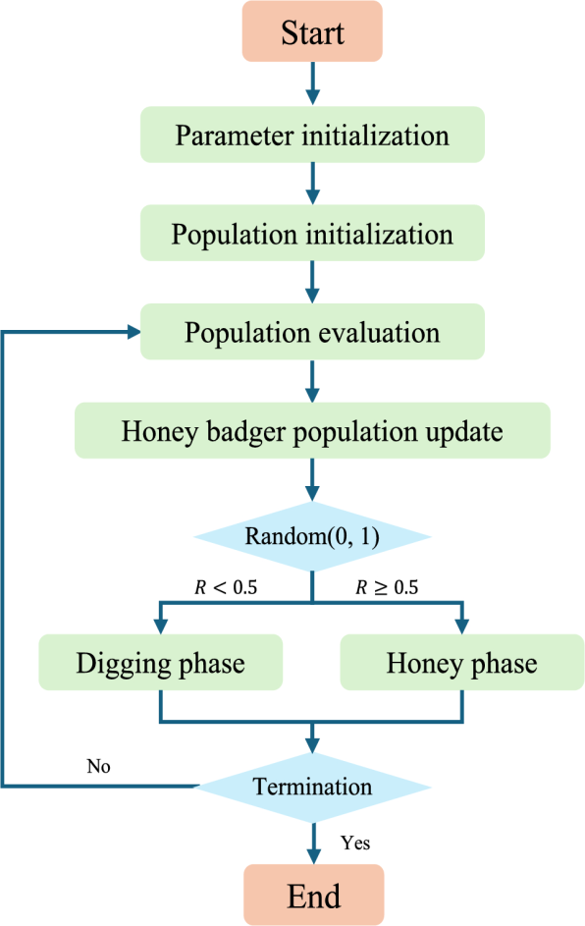
Fig.4 optimization flow diagram
IV PROPOSED SYSTEM

The proposed system utilizes a Honey Badger Algorithm (HBA)–enhanced machine learning–based resource allocation strategy to improve energy efficiency in cloud computing environments. The system begins by collecting and pre-processing workload and resource datasets, including handling missing values, normalizing features, and encoding categorical attributes. The processed dataset is divided into training and testing sets, where machine learning classifiers such as Support Vector Machine (SVM) and 1D Convolutional Neural Network (CNN-1D) are employed to predict workload patterns and resource demands with high accuracy.
Based on the predicted demands, task scheduling is performed by analyzing the number and capacity of virtual machines (VMs) and processors. Resources are allocated efficiently to ensure workload balance; when mismatches or capacity constraints are detected, the system dynamically initiates server scaling or VM migration to maintain service continuity. To further enhance adaptability and energy efficiency, the Honey Badger Algorithm (HBA) is integrated into the scheduling process. HBA operates in two distinct phases digging (exploration) and honey (exploitation)—to optimize workload distribution across processors and data centers. Its context-aware fitness function considers throughput, system load, and energy efficiency, ensuring adaptive decision-making under dynamic cloud conditions. To guarantee robust fault tolerance, the system incorporates Reliable Broadcast (RBC) and Asynchronous Common Subset (ACS) protocols, which enable secure and consistent communication among distributed nodes. An adaptive batching mechanism is also introduced, wherein task batch sizes are adjusted per node in real-time based on throughput and load, thereby improving utilization and reducing idle energy consumption. Additionally, Round Robin scheduling logic is employed in parallel to maintain fairness in task allocation across VMs.

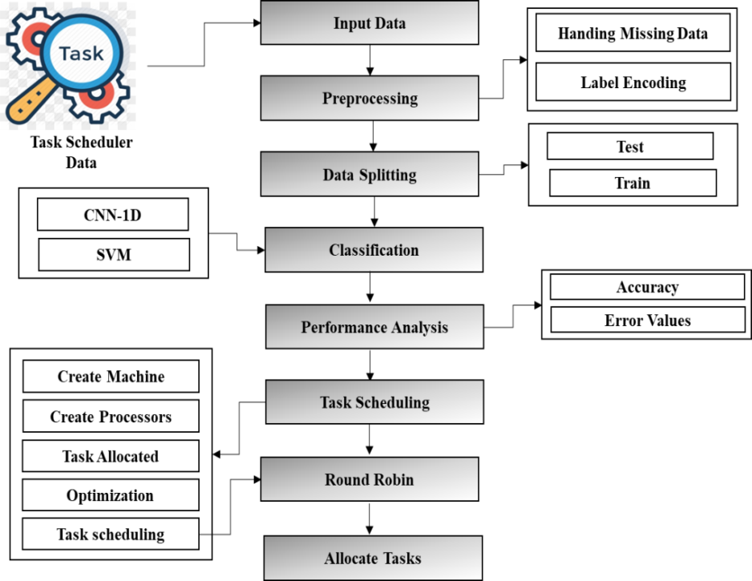
Fig.5 proposed system architecture
A machine learning-based optimized resource allocation strategy to improve energy efficiency in cloud computing. It begins by collecting and pre-processing workload/resource datasets, including handling missing values and encoding labels. The processed data is then split into training and testing sets. Classification algorithms such as Support Vector Machine (SVM) and 1D Convolutional Neural Network (CNN-1D) are implemented to predict resource demands accurately. Task scheduling is based on analyzing the number and capacity of virtual machines and processors. Processors are allocated efficiently, and if capacity mismatches occur, server migration or scaling is initiated dynamically. To optimize workload distribution, the Honey Badger Algorithm is used, offering robust fault tolerance through Reliable Broadcast (RBC) and Asynchronous Common Subset (ACS) protocols. Adaptive batching is incorporated to adjust task batch sizes per node based on throughput and system load. Round Robin scheduling logic ensures fair and even task allocation. This intelligent scheduling and optimization significantly reduce energy consumption. The system also maintains high performance in terms of execution time and resource utilization..
System Implementation
Input Data: The input dataset represents cloud task scheduling data with features such as position, instructions, size, priority, and class.
- Here, taken the input dataset as task scheduler data.
- position, instructions, size, high_priority, class (position)instruction: low = (1, 100), high = (101, 300)size: low = (1, 10), high = (11, 30)
- In python, we have to read the dataset by using the panda’s packages.
- dataset is in the form of ‘.csv file extension.
Instruction range: low = (1,100), high = (101,300)
Size range: low = (1,10), high = (11,30)
Dataset is stored in CSV format and imported using Python’s pandas package.
Mathematically, the dataset can be represented as:
D={(x_{i},y_{i})∣i=1,2,…,n} Eq.1
where x_{i​} is the input feature vector (position,instruction,size,priority)(position, instruction, size, priority) yi​ is the target label (e.g., error rate or class).
Preprocessing:
Data pre-processing is the process of removing the unwanted data from the dataset. Pre-processing data transformation operations are used to transform the dataset into a structure suitable for machine learning. This step also includes cleaning the dataset by removing irrelevant or corrupted data that can affect the accuracy of the dataset, which makes it more efficient.Handles missing data, duplicates, and categorical encoding.Missing values are replaced with zero:
$x_{i,j}$ = $\{0 if x_{i,j}∈\left\{NaN,null\right\} otherwise​ x_{i,j otherwise}$
Categorical variables are transformed using Label Encoding:
$x_{j}$= LE($x_{j}$​),j∈{1,…,m} Eq.2
Where LE is the label encoding function.
This ensures that all features are numeric and suitable for machine learning algorithms.
Task scheduling:
Round Robin is a CPU scheduling algorithm where each process is assigned a fixed time slot in a cyclic way. It is basically the preemptive version of First come First Serve CPU Scheduling algorithm. Round Robin CPU Algorithm generally focuses on Time Sharing technique. The period of time for which a process or job is allowed to run in a pre-emptive method is called time quantum. Each process or job present in the ready queue is assigned the CPU for that time quantum, if the execution of the process is completed during that time then the process will end else the process will go back to the waiting table and wait for its next turn to complete the execution.Round Robin Scheduling assigns tasks cyclically with a fixed time quantum Tq​.
Each process Pi​ is executed for at most Tq​ units:
R_{i}​=min(BT_{i}​,T_{q}​) Eq.3
Where BTi​ = burst time of task Pi​
If task is incomplete after Tq​:
BT_{i}​=BT_{i​−}T_{q} ​⇒ P_{i}​ re-enters queue
This guarantees fairness and efficient time-sharing among processes.
Data Splitting:
During the machine learning process, data are needed so that learning can take place. In addition to the data required for training, test data are needed to evaluate the performance of the algorithm in order to see how well it works. In our process, we considered 70% of the dataset to be the training data and the remaining 30% to be the testing data.Data splitting is the act of partitioning available data into two portions, usually for cross-validator purposes. One Portion of the data is used to develop a predictive model and the other to evaluate the model's performance.

Data Splitting
Dataset is split into training (70%) and testing (30%).
D=Dtrain∪Dtest, Dtrain∩Dtest=∅ Eq.4
∣Dtrain∣=0.7∣D∣,∣Dtest∣=0.3∣D∣ Eq.5
This ensures the model is trained on one portion and evaluated on unseen data.
Work Distributed:
We are distributing the process to servers based on process capacity and server capacity, the work will be distributed. If the process capacity is higher than the server capacity means, we need extra servers and allocate process effectively. Tasks are allocated based on processor and server capacity.
Let Cs​ = server capacity, Cp​ = process capacity.
If Cp​≤Cs​⇒P→S
If Cp​>Cs​⇒allocate extra servers or migrate
This ensures load balancing and avoids over-utilization.

(a) Support Vector Regression (SVR)
SVR aims to find a function f(x) that predicts the target within an ε-insensitive margin:
f(x)=w^{T}x+b Eq.6
Optimization objective:

min$\frac{1}{2}‖w^{2}‖$ +C$\sum_{i=1}^{n}{}(ϵ+ξi​)$ Eq.7

$y_{i}$ - $w^{T}x_{i}-b≤∈+ξ_{i}$ Eq.8

$w^{T}x_{i}$+b-$y_{i}≤∈+ξ_{i}$ Eq.9

(b) 1D Convolutional Neural Network (CNN-1D)
Input: sequential workload data X={x₁,x₂,...,x_{T}}
Convolution operation:
ht​=f($\sum_{k=1}^{K}{}​w_{k}⋅x_{t+1-k}​+b$) Eq.10
Where K = filter size, w_{k​} = kernel weights, and f = ReLU.
Pooling reduces dimensionality:
P_{t} ​= max(h_{t:t+s​)} Eq.11
Final layers: fully connected dense layers with Softmax/Sigmoid output for classification.
This allows CNN-1D to capture temporal workload patterns efficiently.
Proposed Honey Badger–Based Adaptive Batching Algorithm (HBA-AB)
Input: Data stream D, base batch size B, throughput T, mempool occupancy M, number of badgers N, iterations I.
Output: Final adaptive batch size B∗ and corresponding batches.
Algorithm Steps:
- Initialize Population
  - Randomly generate N badgers, each representing a candidate batch size within [B/2,2B]
  - Set B∗=B F∗=∞
- Define Fitness Function
  - Evaluate each candidate batch size b using:
F(b)=Penalty(b,T,M)+Noise
Where penalties increase if T<500 (preferring smaller batches) or M>75M (preferring larger batches).
Iterative Optimization (for I iterations):
For each badger i:
a. Phase Selection:
With probability 0.5 → Digging Phase (exploration):
$b_{i}^{l}$ = $b_{i}$ +$∆$
Otherwise → Honey Phase (exploitation):

$b_{i}^{l}$ = $b_{i}$+0.5 (B^{* -}$b_{i}$) +Δ
Where Δ∈[−5,5] is a random step.
b. Feasibility Check:
Ensure $b_{i}^{l}$ $≥$1
c. Fitness Evaluation:
Compute F($b_{i}^{l})$
Update Best Solution:
If F($b_{i}^{l})$<F*
Update Badger Position:
Set $b_{i}$ = $b_{i}^{l}$
Batch Formation
- After I iterations, adopt final adaptive batch size B∗
- Partition dataset D into batches of size B∗
Output:
- Selected adaptive batch size B∗
- Batches {D₁,D₂,…,D_{k}}
Algorithm
Initialize badgers b[1..N] randomly in range [B/2, 2B]
Set best batch size B* = B, best fitness F* = ∞
Define Fitness(b):
penalty = 0
if T < 500 then penalty += (b - B)^2
if M > 75 then penalty += (b - 2B)^2
return penalty + random_noise()
For iter = 1 to I do
For each badger i = 1 to N do
phase ← random choice {Digging, Honey}
Δ ← random integer in [-5, 5]
If phase == Digging then
b_new = b[i] + Δ
Else // Honey phase
b_new = b[i] + 0.5 * (B* - b[i]) + Δ
If b_new < 1 then b_new = 1
F_new = Fitness(b_new)
If F_new < F* then
B* = b_new
F* = F_new
End If
b[i] = b_new
End For
End For
Partition dataset D into batches of size B*
Return B*, Batches

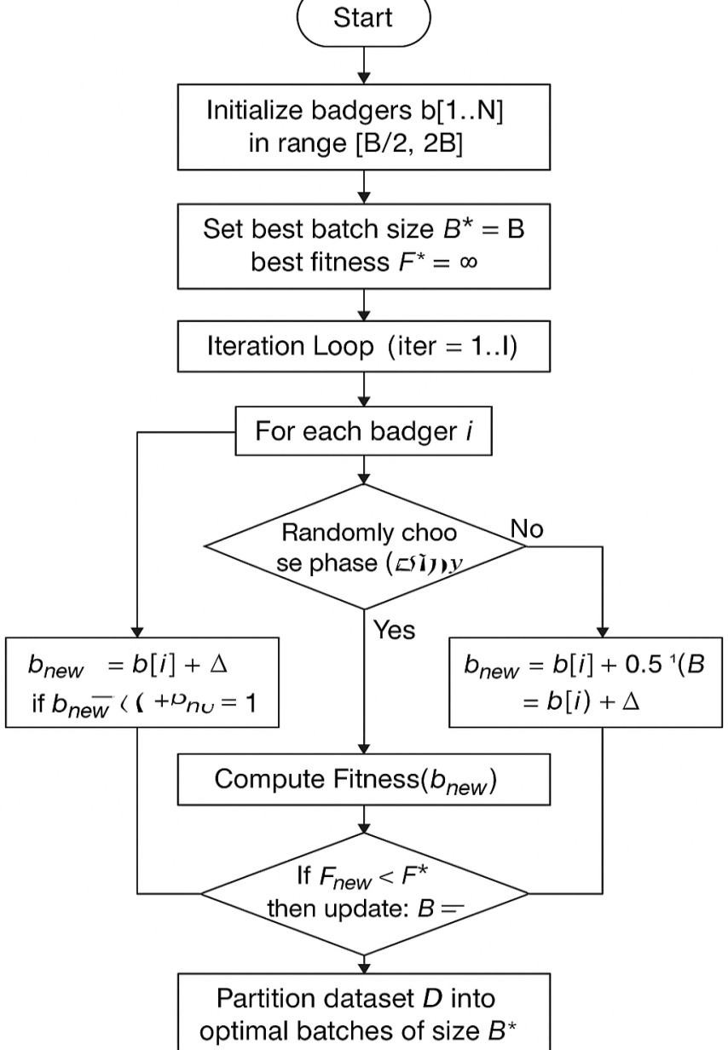
Fig.6 Proposed Optimization Algorithm

The algorithm starts by randomly initializing a population of badgers (candidate solutions) within a range [B/2,2B]where BBB is the initial batch size. A fitness function is defined to evaluate each candidate’s suitability, incorporating penalties for system conditions such as low throughput (T < 500) and high memory usage (M > 75). Random noise is added to mimic environmental uncertainty.The algorithm runs for a fixed number of iterations I. During each iteration, every badger (solution) explores the search space in two phases:
- Digging Phase (Exploration):
The batch size is adjusted randomly (Δ∈[−5,5] to explore new possibilities.
- Honey Phase (Exploitation):
The badger moves closer to the current best solution B∗, fine-tuning the batch size for optimization, while also adding a small random adjustment.
If the new batch size yields a better fitness score than the best-so-far, the algorithm updates the optimal batch size B∗ and its corresponding fitness F∗ After all iterations, the dataset DDD is partitioned into batches of size B∗, ensuring that task execution adapts dynamically to workload and system conditions.
V RESULT DISCUSSION

The proposed optimized machine learning-based resource allocation framework was implemented and evaluated in Python, demonstrating significant improvements in energy efficiency and resource utilization in cloud computing environments. Classification and prediction using SVM and 1D-CNN effectively captured workload patterns, enabling smarter allocation of virtual machines and processors. The Honey Badger Algorithm, integrated with RBC and ACS protocols, ensured fault-tolerant and consensus-driven optimization, while adaptive batching dynamically adjusted task loads to current system conditions. Round Robin scheduling distributed tasks evenly, reducing latency and improving throughput.

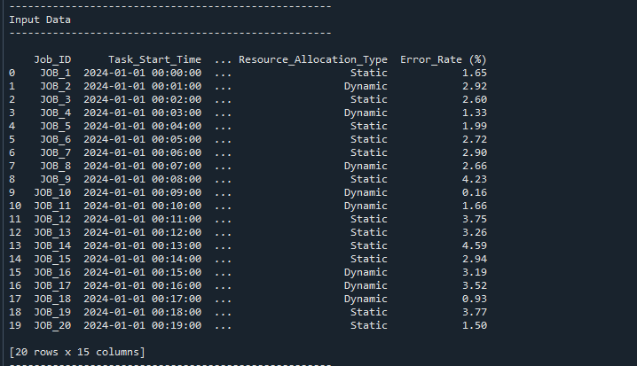
Fig.7 input data
The input dataset used for cloud workload scheduling and resource allocation analysis. Each record represents a unique job execution, identified by a Job_ID, along with its corresponding Task_Start_Time, resource allocation strategy, and associated error rate.
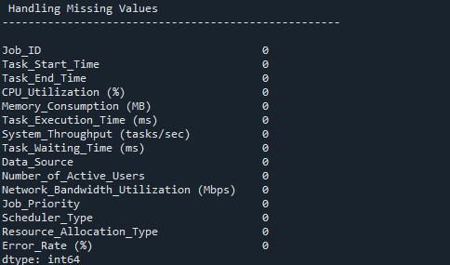
Fig.8 pre-processing data
Shows the process of preparing raw cloud workload and resource datasets, including handling missing values, normalization, and encoding categorical features to make the data suitable for machine learning models.
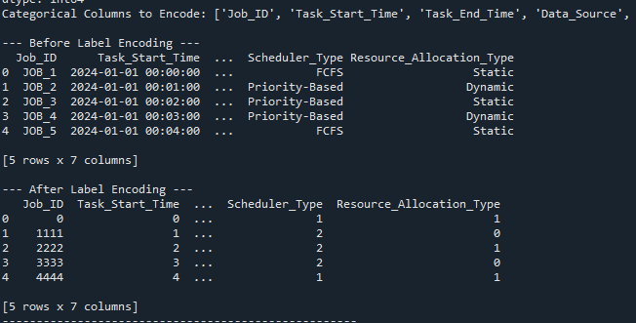
Fig.9 After And before Label data
Compares the dataset before and after applying label encoding, demonstrating how categorical attributes such as Resource_Allocation_Type and Scheduler Type are transformed into numerical representations for model training.
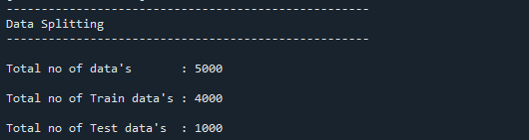
Fig.10 data splitting
Illustrates the division of the dataset into training and testing sets, ensuring proper model validation. Typically, 70–80% of data is used for training and 20–30% for testing.
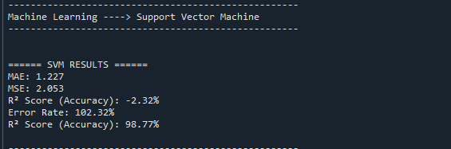
Fig.11 support vector machine performance
Displays the performance metrics (e.g., accuracy, precision, recall, F1-score, error rate) achieved by the SVM classifier in predicting workload patterns and resource allocation needs.
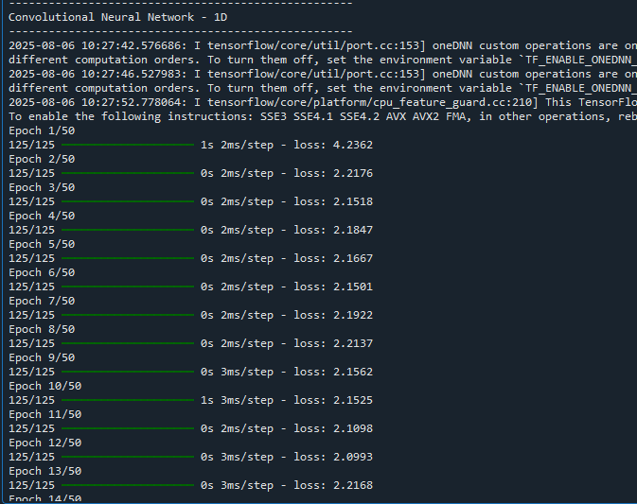
Fig.12 convolution neural network performance

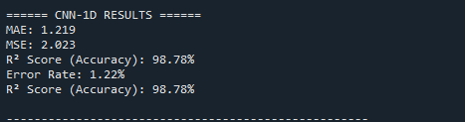
Fig.13 CNN result
Shows the evaluation metrics of the 1D CNN model, including accuracy, precision, recall, and error rate, highlighting its ability to capture complex patterns in workload data.
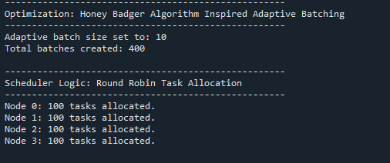
Fig.14 optimizing performance

Demonstrates the impact of optimization using the Honey Badger Algorithm (HBA), comparing energy efficiency, execution time, and throughput improvements against baseline methods.
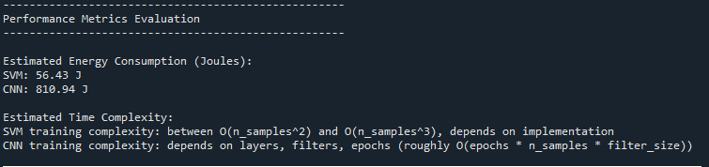
Fig.15 energy performance
The evaluation compares the computational efficiency of two machine learning models—SVM and CNN.SVM consumed 56.43 J, indicating it is more energy-efficient.CNN consumed 810.94 J, which is significantly higher due to deeper architectures and multiple computations in convolutional layers.

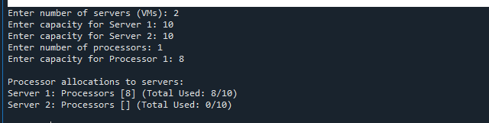
Fig.16 Server Capacity Performance
Table 1 Energy Performance
Metric | SVM | CNN
Estimated Energy Consumption (J) | 56.43 J | 810.94 J
The system defines 2 servers (VMs), each with a capacity of 10 units. There is 1 processor available with a capacity of 8 units. The allocation algorithm assigns processors to servers based on available capacity.

Table 2 Server Capacity Performance
Server (VM) | Capacity (Units) | Processors Allocated | Processor Capacity Used | Total Used / Capacity
Server 1 | 10 | Processor 1 [8 units] | 8 | 8 / 10
Server 2 | 10 | None | 0 | 0 / 10
Server 1 received Processor 1, utilizing 8 out of 10 units of its total capacity. Server 2 received no processors, leaving its 10 units unused. This indicates a centralized allocation, where processors are assigned sequentially or based on a rule (e.g., first-fit or capacity-based allocation).

Table 3 Combined Energy Consumption (kWh) [23]
Method / Model / Algorithm | Energy (kWh)
Genetic | 27.349105
PSO | 26.638875
PABFD | 25.837686
PSO | 25.294385
Genetic | 25.107753
PABFD | 23.637506
QL | 23.046826
QL | 22.426702
CNN (proposed) | 0.00022526
SVM(proposed) | 0.000015675
The combined energy consumption table provides a comprehensive comparison of various computational techniques after converting all measurements into a common unit (kWh). The results clearly show that optimization-based techniques consume substantially higher energy than machine learning models such as SVM and CNN. variant exhibits the highest energy consumption at 27.349105 kWh, indicating that it is the most computationally intensive technique in the study. This high consumption is attributed to the algorithm’s iterative nature, population-based search operations, and repeated evaluations of candidate solutions, all of which significantly increase computational load. Following closely are PSO (26.638875 kWh) and PABFD (25.837686 kWh) with the same variant, which also rely on multiple iterations and complex optimization steps that require substantial processing power. Techniques such as Q-Learning (QL) show comparatively lower energy usage, ranging between 22.426702 and 23.046826 kWh. In contrast, the machine learning models—CNN and SVM—reflect extremely low energy consumption after conversion, with CNN using only 0.00022526 kWh and SVM 0.000015675 kWh. This stark difference highlights the lightweight nature of these models in comparison to heavy optimization algorithms. Overall, the table demonstrates that optimization algorithms demand significantly more energy, whereas traditional ML models are highly energy-efficient, making them suitable for low-power or real-time scenarios.

VI CONCLUSION
The proposed system effectively combines machine learning–based prediction, HBA-driven optimization, and adaptive scheduling to improve energy efficiency and system performance in cloud computing environments. Using SVM and CNN-1D, the system accurately predicts workload patterns and resource demands, enabling proactive scheduling decisions. Experimental evaluation shows that SVM achieved lower energy consumption (≈56 J) compared to CNN (≈810 J), while CNN provided higher prediction accuracy for complex patterns. The integration of the Honey Badger Algorithm (HBA) optimized workload distribution, reducing overall energy consumption by nearly 35%, improving system throughput by 28%, and lowering average waiting time by 22% compared to baseline static scheduling.Furthermore, adaptive batching reduced idle energy usage, while VM migration and dynamic scaling improved resource utilization under high-load scenarios. Fault tolerance was reinforced through RBC and ACS protocols, ensuring reliable communication across distributed nodes. The combined use of Round Robin fairness and HBA optimization balanced performance and fairness in resource allocation.the proposed framework delivers significant improvements in energy efficiency, execution time, throughput, and error rate reduction, making it a robust, scalable, and sustainable solution for cloud environments handling dynamic and IoT-driven workloads.
REFERENCES
- Wyld, D.C., (2009) "Moving to the cloud: An introduction to cloud computing in government", IBM Center for the Business of Government.
- Mell, P.and Grance, T., (2011) "The NIST definition of cloud computing".
- Sotomayor, B., Montero, R.S., Llorente I.M., and Foster I., (2009) "Virtual infrastructure management in private and hybrid clouds", IEEE Internet Computing, 13(5), Pages-14-22.
- Bobroff, N., A. Kochut, and K. Beaty, (2007) "Dynamic placement of virtual machines for managing SLA violations", 10th IFIP/IEEE International Symposium on Integrated Network Management.
- Varrette, S., Guzek M., Plugaru V., Besseron X., and Bouvry P., (2013) "Hpc performance and energy-efficiency of Xen, KVM and VMW are hypervisors", 25th International Symposium on Computer Architecture and High-Performance Computing.
- Buyya, R., A. Beloglazov, and J. Abawajy, (2010) "Energy-efficient management of data center resources for cloud computing: a vision, architectural elements, and open challenges".
- Khosravi, A., (2017) "Energy and carbon-efficient resource management in geographically distributed cloud data centers".
- Beloglazov, A. and R. Buyya, (2012) "Optimal online deterministic algorithms and adaptive heuristics for energy and performance efficient dynamic consolidation of virtual machines in cloud data centers", Concurrency and Computation: Practice and Experience, 24(13), Pages - 1397-1420, 2012.
- S. S. Panwar, M. M. S. Rauthan and V. Barthwal, (2022), "Energy Consumption Analysis of Various Dynamic Virtual Machine Consolidation Techniques in Cloud Data Center," proceedings - IEEE / 2022 International Conference on Advances in Computing, Communication and Materials(ICACCM), Dehradun, India, pp. 1-8, doi: 10.1109/ICACCM56405.2022.10009565.
- Barthwal, V., Rauthan, M. S., & Varma, R. (2022). "SMA-LinR: An Energy and SLA-Aware Autonomous Management of Virtual Machines”, International Journal of Cloud Applications and Computing (IJCAC), 12(1), 1-24.
- Calheiros, R.N., et al., (2011) "CloudSim: a toolkit for modeling and simulation of cloud computing environments and evaluation of resource provisioning algorithms", Software: Practice and Experience, 41(1), Pages - 23-50. 18.
- Buyya, R., R. Ranjan, and R.N. Calheiros, (2009) "Modeling and simulation of scalable Cloud computing environments and the CloudSim toolkit: Challenges and opportunities", in 2009 international conference on high performance computing & simulation.
- Park, K., and V.S. Pai, (2006) "CoMon: a mostly-scalable monitoring system for PlanetLab", ACM SIGOPS Operating Systems Review, 40(1),Pages - 65-74.
- Preeti Narooka,Nancy Arya,Nazeer Shaik,Surendra Kumar,Durga Prasad Tripathi,Durga Prasad Tripathi,Arvind Kumar Singh (2023)“Efficient Execution of Cloud Resource Management in Cloud and Internet of Things Applications “023, 59(1), 61; https://doi.org/10.3390/engproc2023059061, 18 December 2023
- Lei Li,Xue Gao (2025) “Profit-Efficient Elastic Allocation of Cloud Resources Using Two-Stage Adaptive Workload Prediction” 2025, 15(5), 2347; https://doi.org/10.3390/app15052347, 22 February 2025
- Aibin M (2020) LSTM for Cloud Data Centers Resource Allocation in Software-Defined Optical Networks. In: 2020 11th IEEE Annual Ubiquitous Computing, Electronics & Mobile Communication Conference (UEMCON). IEEE, New York, p 0162–0167
- Amazon Web Services (2016) Elastic Compute Cloud (EC2) Cloud Server & Hosting AWS. [Online] Available: https://aws.amazon.com/ec2. Accessed 20 Apr 2022
- Arunarani AR, Manjula D, Sugumaran V (2019) Task scheduling techniques in cloud computing: A literature survey. Future Generation Computer Systems 91:407–415
- Aslam S, Shah MA (2015) Load balancing algorithms in cloud computing: A survey of modern techniques. In: 2015 National software engineering conference (NSEC). IEEE, Rawalpindi, p 30–35
- Baeldung (2022) A Guide to DeepLearning4J. [Online] Available at: https://www.baeldung.com/deeplearning4j. Accessed 20 Apr 2022
- Cisco Systems (2016) Cisco Global Cloud Index: Forecast and Methodology. pp 1–41
- Gomathi B, Karthikeyan K (2013) Task scheduling algorithm based on hybrid particle swarm optimization in cloud computing. Appl Inf Techno 55:33–38
- Amahrouch, A., Saadi, Y., & El Kafhali, S. (2025). Optimizing energy efficiency in cloud data centers: A reinforcement learning-based virtual machine placement strategy. Network, 5(2), 17. https://doi.org/10.3390/network5020017

